**Happy Shopping**

**-Billing Application**

***Dissertion Submitted in Partial fulfillment of the Requirement for the Award of the Degree of***

***Bachelor of Computer Application***

***Semester IV***

***January - May, 2020***

Under the guidance of - Submitted By-

Ms. Sunita Gaur Vaishnavi Bhavsar

Nihal Patel

Yeshi Singh Kushwaha

## School of Computer Science & IT

## Devi Ahilya Vishwavidyalaya, Indore, M.P.

**2020**

**School of Computer Science & IT**

**Devi Ahilya Vishwavidyalaya, Indore, M.P.**

**DECLARATION**

I hereby declare that the project titled “**HAPPY SHOPPING**” submitted by Ms. Yeshi Singh Kushwaha , Ms. Vaishnavi Bhavsar and Mr. Nihal Patel for the partial fulfillment of the requirement for the award of *Bachelor of Computer Applications* to *School of Computer Science & IT, Devi Ahilya Vishwavidyalaya, Indore,* comprises our work and due acknowledgement has been made in text to all other material used.

Signature of Students:

Date: 10th September, 2020

Place: School of Computer Science and IT, DAVV, Indore

## School of Computer Science & IT

**Devi Ahilya Vishwavidyalaya, Indore, M.P.**

**CERTIFICATE FROM GUIDE**

It is to certify that dissertation on “**HAPPY SHOPPING**”, submitted by Ms. Yeshi Singh Kushwaha , Ms. Vaishnavi Bhavsar and Mr. Nihal Patel to the *School of Computer Science & IT, DAVV*, *Indore* has been completed under my supervision and the work is carried out and presented in a manner required for its acceptance in partial fulfillment for the award of the degree of *Bachelor of Computer Application..*

**Project Guide**

Signature:

**Name: Mrs. Sunita Gaur**

**Date:10thSeptember,2020**

## School of Computer Science & IT Devi Ahilya Vishwavidyalaya, Indore, M.P.

**CERTIFICATE**

It is to certify that we have examined **HAPPY SHOPPING**, submitted by Ms. Yeshi Singh Kushwaha , Ms. Vaishnavi Bhavsar and Mr. Nihal Patel to the *School of Computer Science & IT, DAVV*, *Indore* and hereby accord our approval of it as a study carried out and presented in a manner required for its acceptance and partial fulfillment for the award of the degree of *Bachelor Of Computer Application.*

### **Internal Examiner External Examiner**

Signature: Signature:

Name : Name :

Date : Date :

# **ACKNOWLEDGEMENT**

The success and final outcome of **Bill-Pay** project required a lot of guidance and assistance from many people and we are extremely fortunate to have got this all along the completion of our project work. Whatever we have done is only due to such guidance and assistance and we would not forget to thank them.

We owe our profound gratitude to the Head of our college **Dr. Sanjay Tanwani,** our class coordinator **Mr. Sudhanshu Trivedi** and our project guide **Mrs. Sunita Gaur**, who took keen interest on our project work and guided us all along, till the completion of our project work by providing all the necessary information for developing a web-based application.

We are thankful to and fortunate enough to get constant encouragement, support and guidance from all Teaching staffs of Department of school of computer science & IT which helped us in successfully completing our project work.

**ABSTRACT**

This software project is a traditional supermarket billing system with some added functionality. This system is built for fast data processing and bill generation for supermarket customers. The billing system consists of Access database and effective front end designed in Asp.net. The billing database is a vast collection of product name, price and other product specific data. A product when billed is searched from the database and its price is added to the bill based upon the product quantity. The system also contains discounts on various products so that the product is offered at discounted price while billing. The supermarket billing system is built to help supermarkets calculate and display bills and serve the customer in a faster and efficient manner. This software project consists of an effective and easy Gui to help the employee in easy bill calculation and providing an efficient customer service.

Product identification allows for directly scanning products and their data is added to the system automatically.

CONTENT:

## Chapter I INTRODUCTION

## The e-Billing system has the capacity to illustrate and analyze the basic billing system and the main functionalities that surround the billing system from a business prospective and explains how each interacts to complete the billing cycle.

## Also, development of a billing system emulator that is capable of billing more quickly, accurately and update customer record and enables customer to view bill information.

## This Billing system can be deployed in a real world situation. For example, it could be implemented for any supermarket, general/grocery stores to have effective billing of the customer .

## AIMS AND OBJCTIVES:

## The aim of this project is to create an application that should provide service to the user, collect user usage records, and generate invoices of each credit expire, each billing cycle depends on the billing type, collect payments and adjust customers’ balances.

## Main objective of the project is to illustrate and analyze the basic billing system and the main functionalities that surround the billing system from a business prospective and explains how each interacts to complete the billing cycle, to develop a billing system emulator that can bill more quickly and accurately, to update customer record and to develop a billing system that enables customer to view bill information.

v

### **Challenges of the existing system**

* Traditionally, bills were managed manually on paper.
* It is less user-friendly.
* It is time consuming process for recording details of each and every bill and users.
* Lack of immediate information storage.
* Lack of prompt updating.
* Being unable to update the manual records.
* Preparation of accurate and prompt reports.
* Inability to retain records as they are lost if kept wrongly.

### **Proposed Solution**

To overcome the drawbacks of the existing system, the proposed system has been evolved. This project aims to reduce the paper work and saving time to generate accurate result for the users as well as the manager. It is a web-based bill management platform that facilitates bill management with simpler and convenient tools. The system provides with the best user interface. The efficient reports can be generated by using the proposed system. This system is trouble free to use with relatively fast approach to prepare bills while saving time and is highly reliable. It is a system that provides a platform where one can create and manage inventory. This application is designed in a way to promote feasibility and reduce manual work. The idea is very simple but will turn out to be very helpful and time saving for a particular user because it is completely based on real time issues which a common man faces.

## Chapter II ANALYSIS

### **Business Needs**

The following project’s business needs would be needed by the shopkeepers to manage the customer record in an easier way and to showcase their work through a good interface. This system also makes it easy for a better records maintenance. The data is immediately stored and easy to access whenever required.

### **Functional Requirements**

* These are divided into generate new bill , view bill history, adding/removing inventory items and various ledger accounts.
* The system shall record all the customer details.

## Chapter III Project Planning

Project planning is a part of the project management, which relates to the use of schedules such as charts to plan and subsequently report progress within the project environment. Project planning is often used to organize different areas of a project, including project plans, workloads and the management of teams and individuals. The logical dependencies between tasks are defined using an activity network diagram that enables identification of the critical path. Project planning is inherently uncertain as it must be done before the project is actually started. Therefore the duration of the tasks is often estimated through a weighted average of optimistic, normal, and pessimistic cases.

### The steps followed for the project planning-

* Select a project
* Identifying project’s aims and objectives
* Understanding requirements and specification
* Methods of analysis, design and implementation
* Documentation
* Project Estimation
* Time
* Coding
* Duration
* Resource Allocation
* Hardware requirement
* Software requirement

### **HARDWARE :**

Processor: Intel Core i7

Hard Disk Space: 2TB

Memory : 8GB

### SOFTWARE:

Operating System: Windows 10 Database Server: Ms Access

Front End: Visual Basics 2010

## Chapter IV SYSTEM DESIGN

System design is the solution for the creation of a new system. This phase focuses on the detailed implementation of the feasible system. It emphasis on translating design specification to performance specification. System design has two phases of development.

* Logical design
* Physical design

During the logical design phase the analyst describes inputs (sources), outputs (destinations), databases (data sores) and procedures (data flows) all in a format that meets the user requirements. The analyst also specifies the needs of the user at a level that virtually determines the information flow in and out of the system and the data resources. Here the logical design is done through data flow diagrams and database design. The physical design is followed by physical design or coding. The physical design produces the working system by defining the design specifications, which specify exactly what the candidate system must do. The programmers write the necessary programs that accept input from the user, perform necessary processing on accepted data and produce the required report on a hard copy or display it on the screen.

### Input and Output Design

* + 1. **Input Design**

Input design is the link that ties the information system into the world of its users. The input design involves determining the inputs, validating the data, minimizing the data entry and provides a multi-user facility. Inaccurate inputs are the most common cause of errors in data processing. Errors entered by the data entry operators can be controlled by input design. The user-originated inputs are converted to a computer-based format in the input design. Input data are collected and organized into groups of similar data. Once identified, the appropriate input media are selected for processing. All the input data are validated and if any data violates any

conditions, the user is warned by a message. If the data satisfies all the conditions, it is transferred to the appropriate tables in the database. In this project the student details are to be entered at the time of registration. A page is designed for this purpose which is user friendly and easy to use. The design is done such that users get appropriate messages when exceptions occur.

### Output Design

Computer output is the most important and direct source of information to the user. Output design is a very important phase since the output needs to be in an efficient manner. Efficient and intelligible output design improves the system relationship with the user and helps in decision making. Allowing the user to view the sample screen is important because the user is the ultimate judge of the quality of output. The output module of this system is the selected notifications.

### The general tasks in designing process are:

* + - * Design various locks for overall system processes.
      * Design smaller, compact and workable modules in each block.
      * Design various database structures.
      * Specify details of programs to achieve desired functionality.
      * Design the form of inputs and outputs of the system.
      * Perform documentation of the design.
      * System reviews.

### User Interface Design

User Interface Design is concerned with the overall flow of screens and messages between a user and the computer. It is concerned with everything from starting the system or logging into the system to the eventually presentation of desired inputs and outputs.

### Guidelines for User Interface Design

* The system user should always be aware of what to do next.
* The screen should be formatted so that various types of information, instructions and messages always appear in the same general display area.
* Message, instructions or information should be displayed long enough to allow the system user to read them
* Use display attributes sparingly.
* Default values for fields and answers to be entered by user should be specified.
* A user should not be allowed to proceed without correcting an error.
* The system user should never get an operating system message or fatal error.

### The system is designed to allow users perform following functions

* User can enquire about the events.
* User can register for an event and provide event proposals.
* Users can proposals for vendor-ships.
* Admin can login into the system in order to manage the events.
* Admin can manage all types of events and service providers.

**Design Methodology**

Visual basic.Net was used for the implementation of this e-billing system and invoice emulator, which is one of the latest programming software used now with modern features and it helps users to view the Graphic user interface (GUI).

Microsoft access was used for the backend to store customer database which include their respective details:

Front end: Visual basic.NET

Back end: Microsoft access

VISUAL BASIC USED FOR THE PROJECT

Visual basic is a programming language that translates an abstract idea into a program design we can see on screens. Visual basic presents a three step approach for creating programs which are:

a) To design the appearance of the application.

b) Assign property settings to the objects of your program.

c) Write the code to direct specific tasks at runtime.

### Design Methodology (UML)

UML stands for Unified Modelling Language which is used in object-oriented software engineering. Although typically used in software engineering it is a rich language that can be used to model an application structures, behavior and even business processes.

* + 1. **Database Design**

Database design is the process of producing a detailed data model of database. This data model contains all the needed logical and physical design choices and physical storage parameters needed to generate a design in a data definition language, which can then be used to create a database. A fully attributed data model contains detailed attributes for each entity.

The process of doing database design generally consists of a number of steps which will be carried out by the database designer. Usually, the designer must:

1. Determine the data to be stored in the database.
2. Determine the relationships between the different data elements.
3. Superimpose a logical structure upon the data on the basis of these relationships.

**Our project contains the following data tables:**

1. Login Page
2. Bill
3. Inventory
4. Sales Ledger
5. Sales Return
6. Purchase Ledger
7. Purchase Return
8. Debtors List
9. Store Details
10. Product

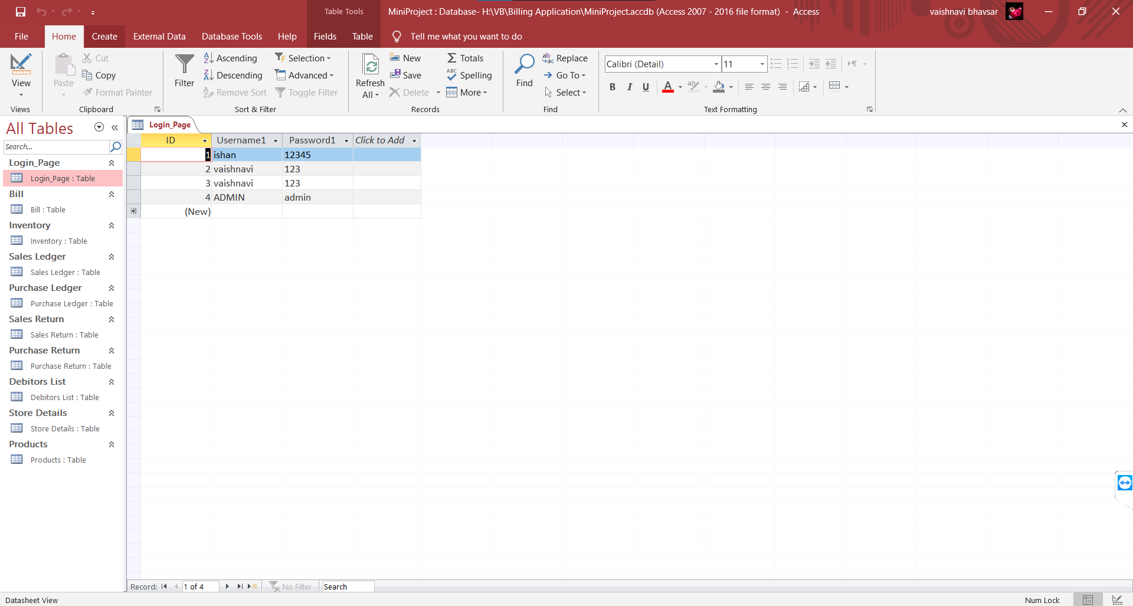

Figure1: Login Page

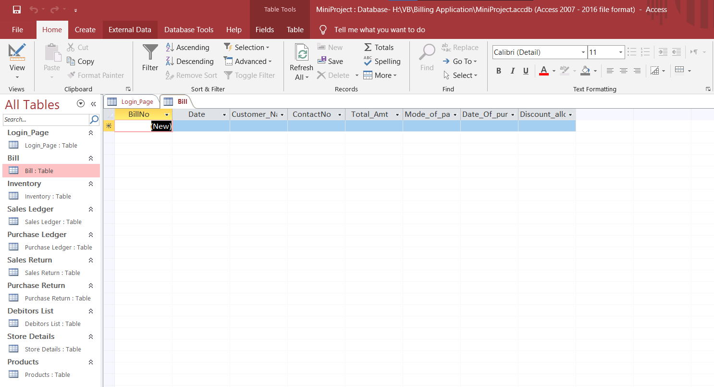

Figure2: Bill

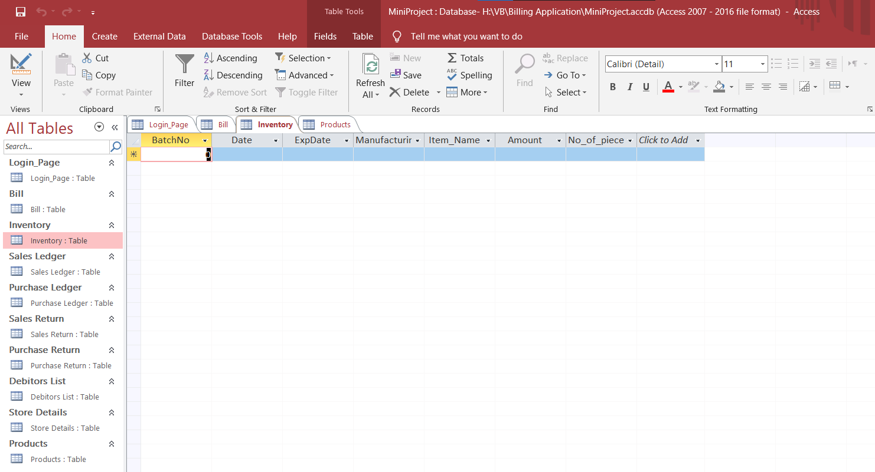

Figure 3: Inventory

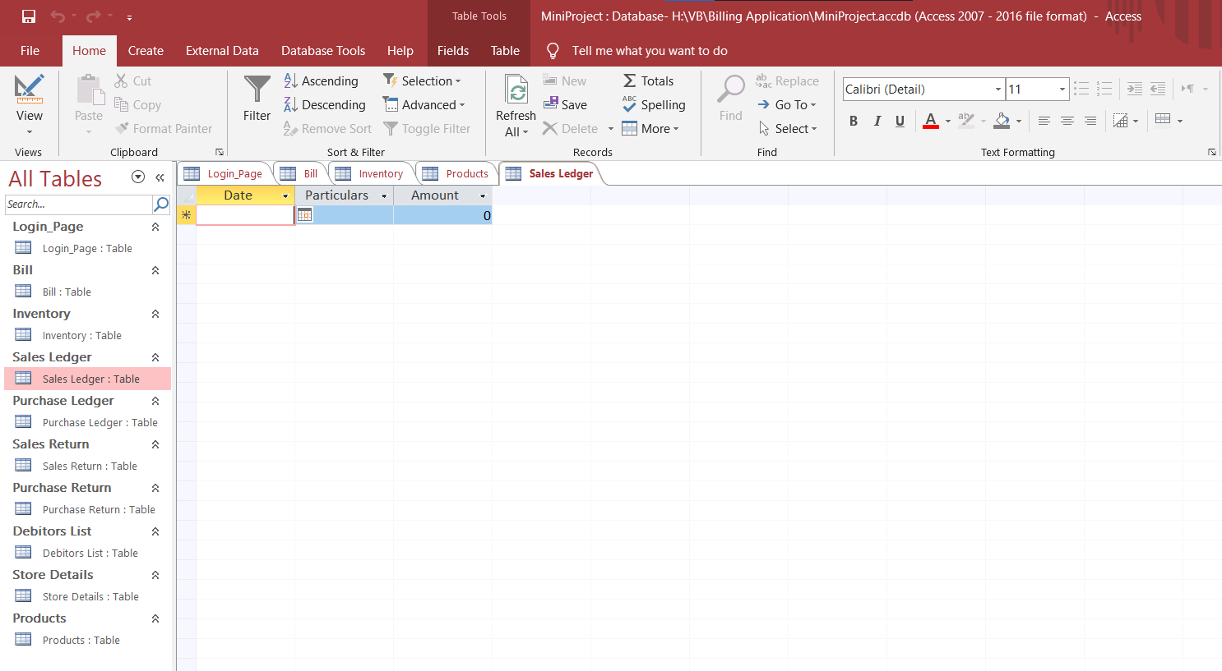

Figure 4 : Sales Ledger

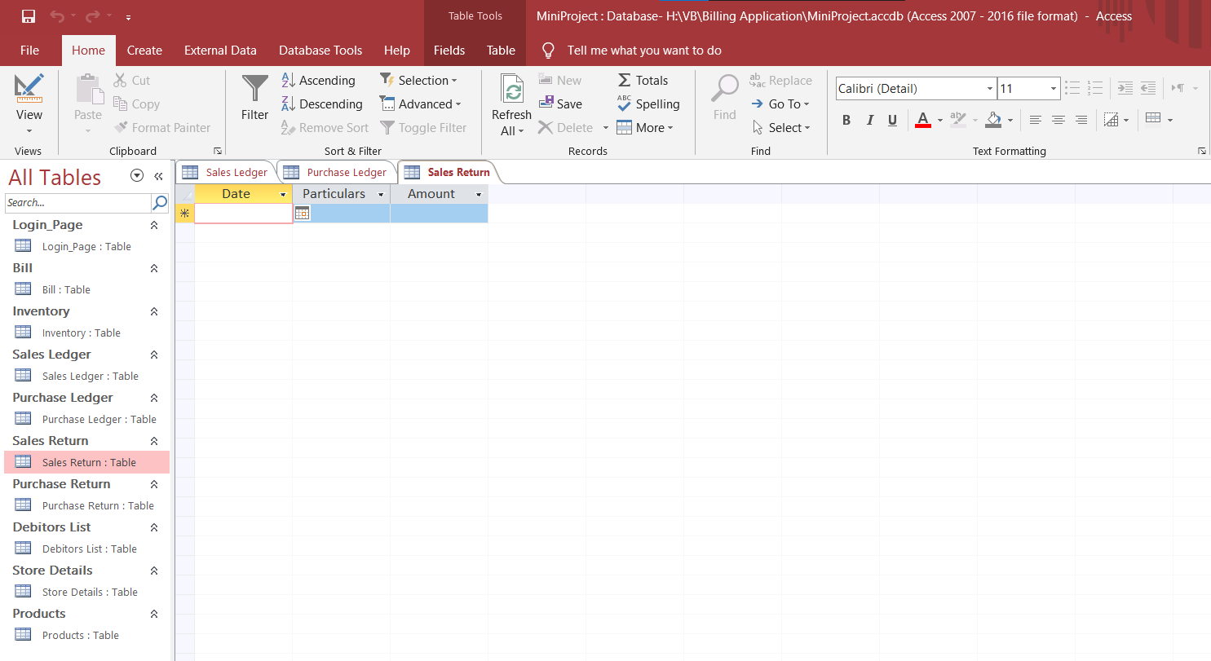

Figure 5: Sales Return Ledger

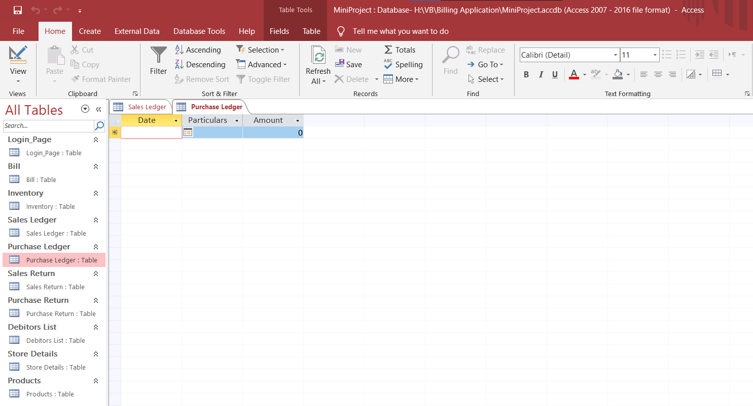

Figure 6: Purchase Ledger

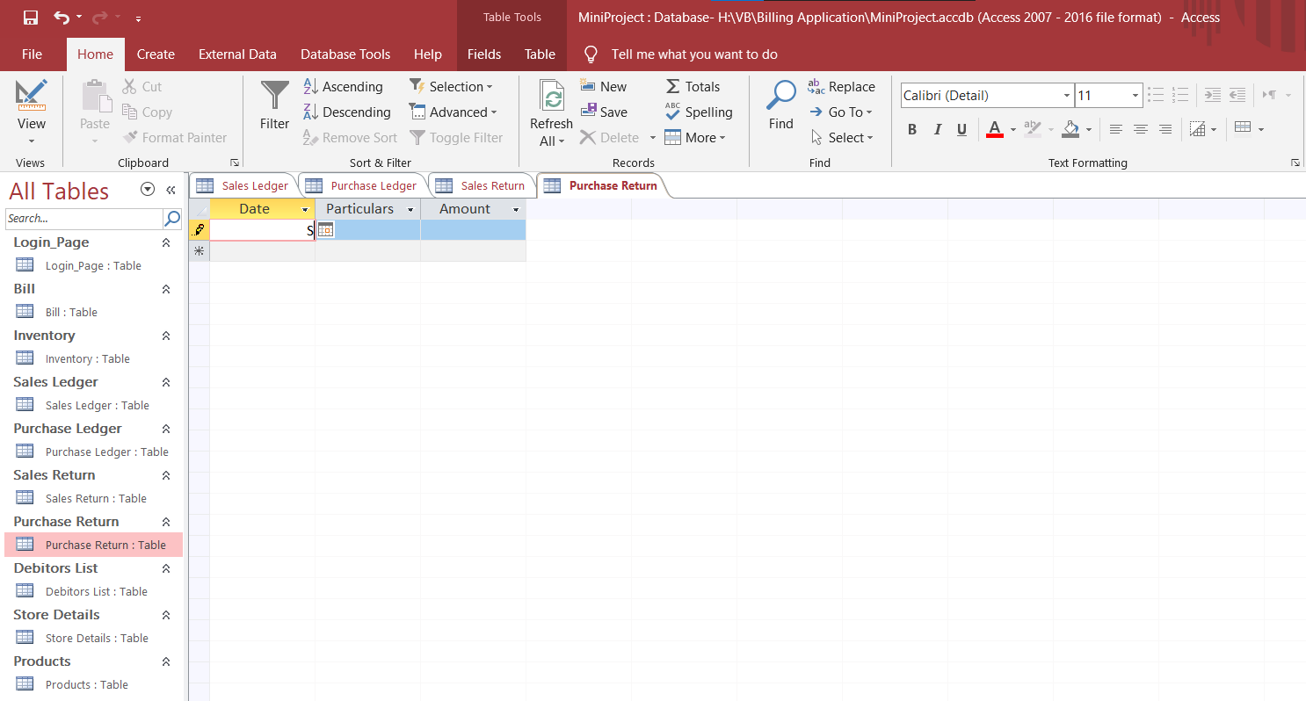

Figure 7: Purchase Return Ledger

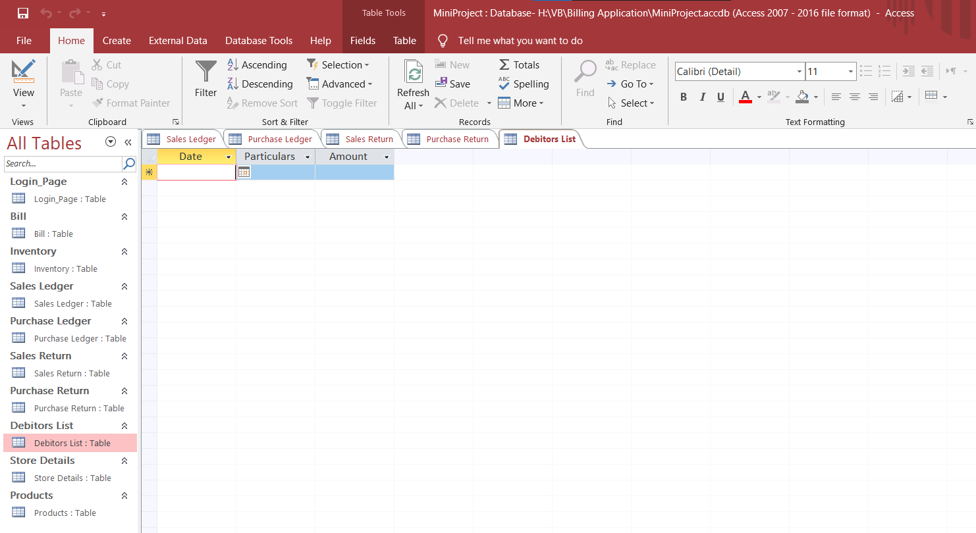

Figure 8: Debitors List

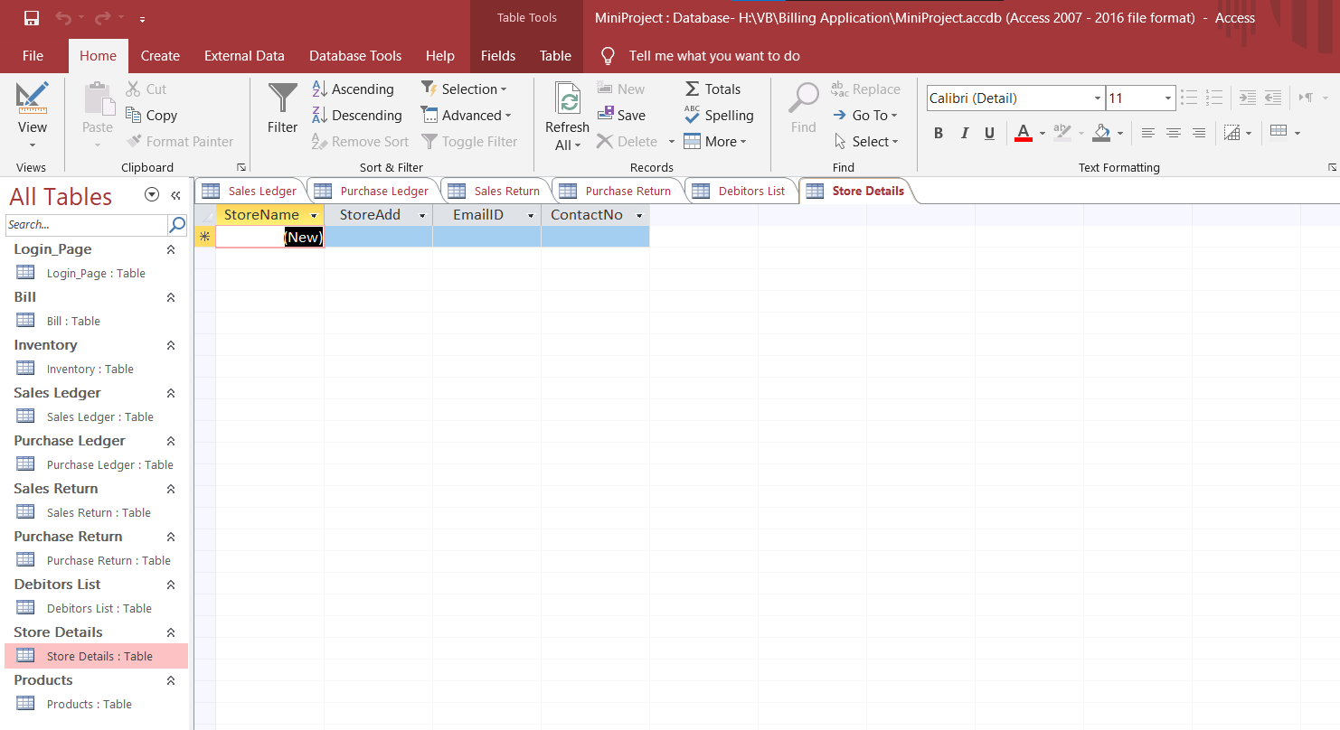

Figure 9: Store Details

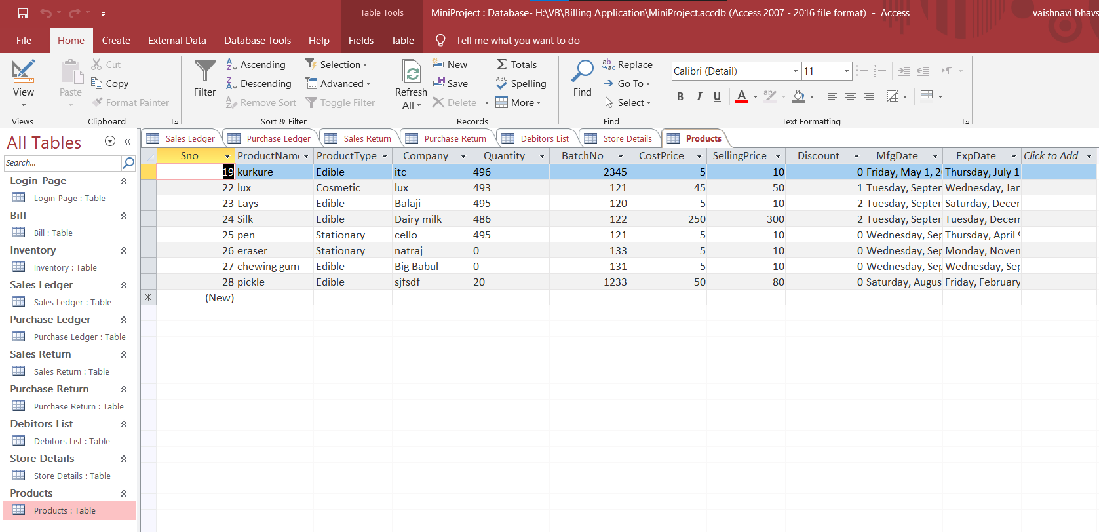

Figure 10: Products

### ER Diagram

An entity relationship model, also called an entity-relationship (ER) diagram, is a graphical representation of entities and their relationships to each other, typically used in computing in regard to the organization of data within databases or information systems.